Exp 1: Create a simple cloud software application and provide it as a service using any Cloud Service Provider to demonstrate Software as a Service (SaaS).
Aim: To create a simple cloud software application and provide it as a service using any cloud service provider todemonstrate software as a service (saas).
Procedure:
Step 1: Go to Zoho.com.
Step 2: Log into the Zoho.com.
Step 3: Select on application step.
Step 4: Enter application name as Hospital Management System.
Step 5: Created new application Hospital Managementn System.
Step 6: Select one form.
Step 7: The software has beem created.
Output:
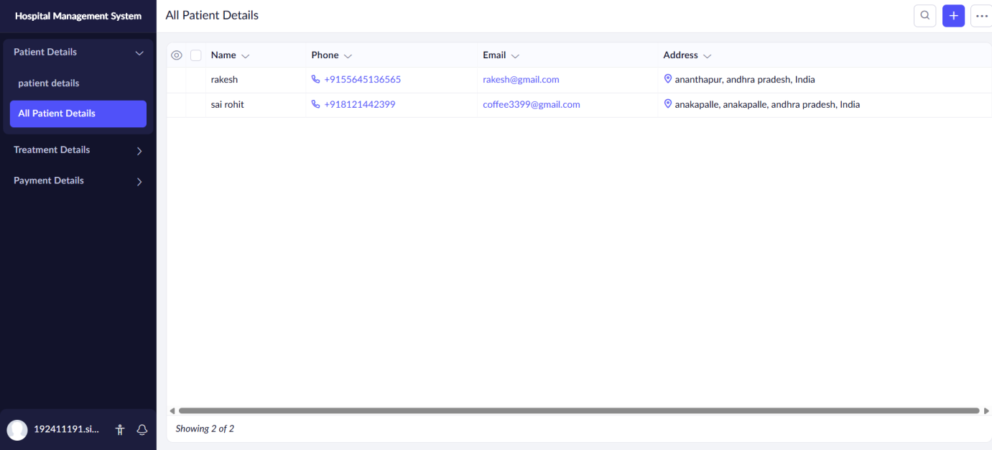
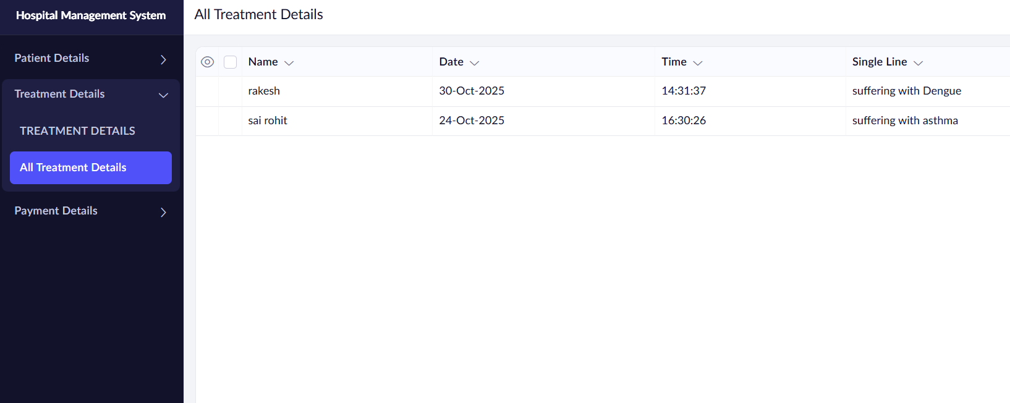

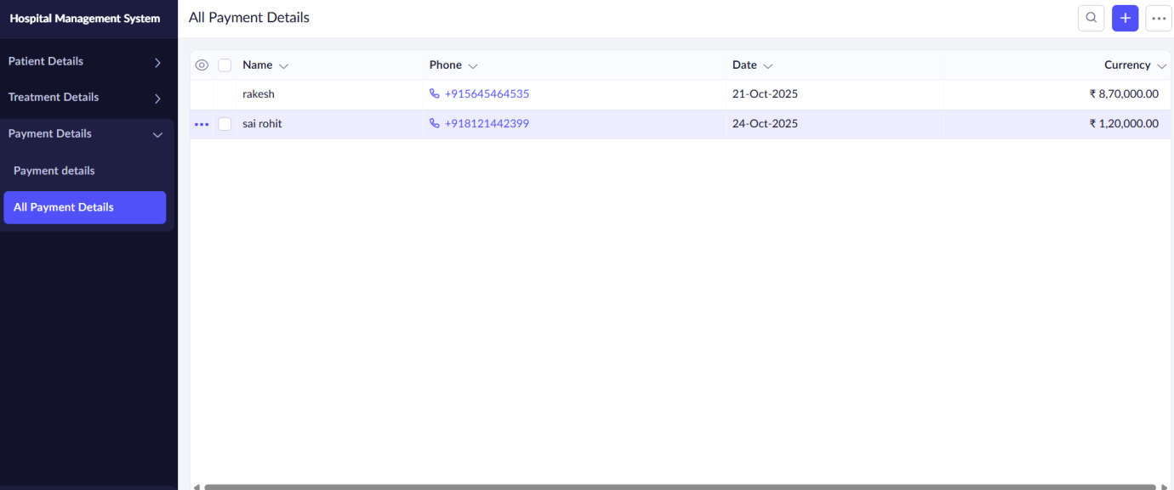

Results: A simple cloud software application and Software as a Service (SaaS)
has been successfully implemented.

